https://aman.ai/coursera-nlp/

Bayes' Rule

Conditional probabilities help us reduce the sample search space. For example given a specific event already happened, i.e. we know the word is happy:

Then you would only search in the blue circle above. The numerator will be the red part and the denominator will be the blue part. This leads us to conclude the following:

Substituting the numerator in the right hand side of the first equation, you get the following:

Note that we multiplied by P(positive) to make sure we don't change anything. That concludes Bayes Rule which is defined as

P(X|Y) = \frac{P(Y|X) P(X)}{P(Y)} *P*(*X*∣*Y*)=*P*(*Y*)*P*(*Y*∣*X*)*P*(*X*)​.

Naive Bayes Introduction

To build a classifier, we will first start by creating conditional probabilities given the following table:

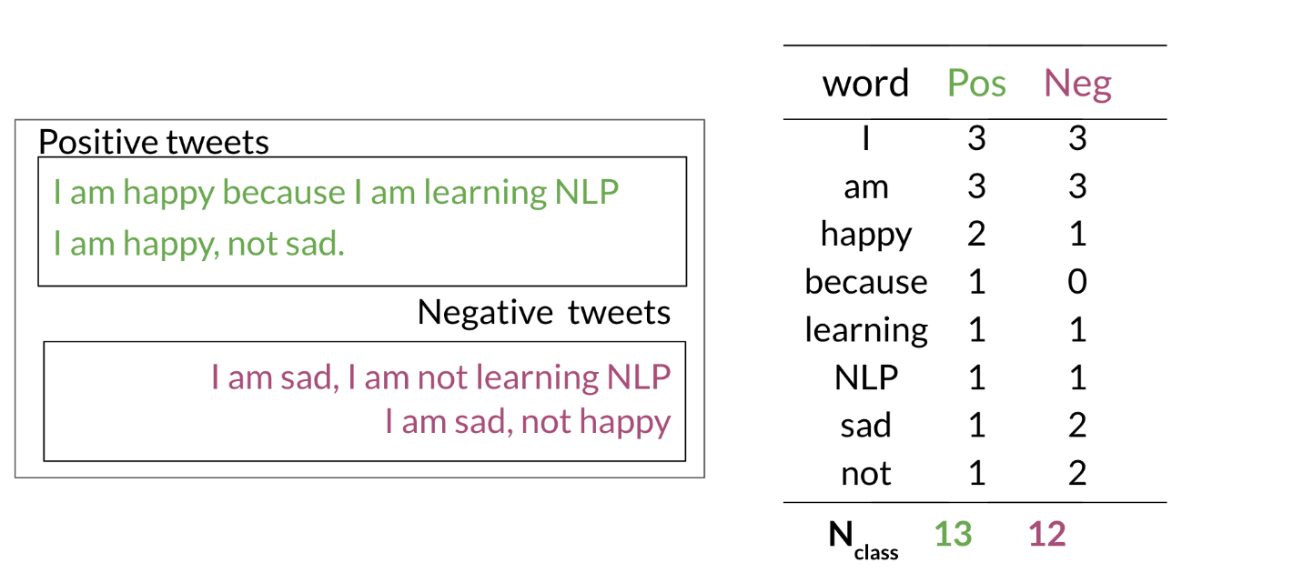

This allows us compute the following table of probabilities:

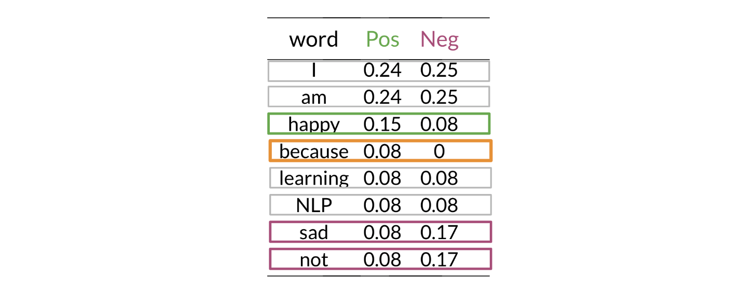

Once you have the probabilities, you can compute the likelihood score as follows

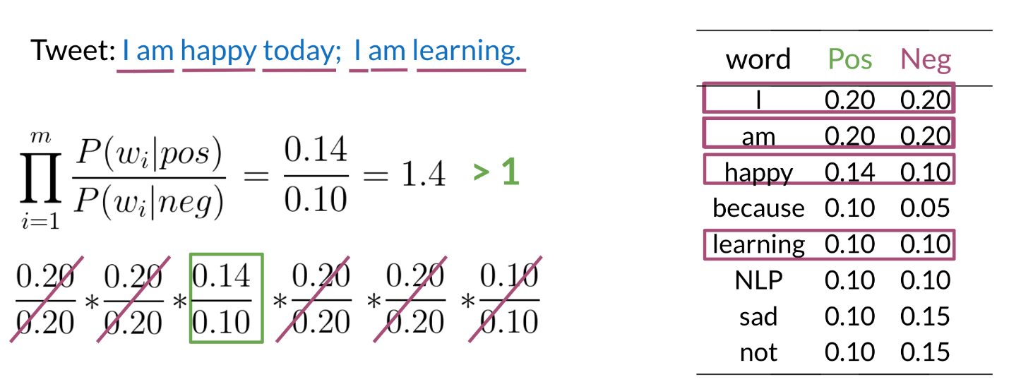

A score greater than 1 indicates that the class is positive, otherwise it is negative.

# Laplacian Smoothing

Method to avoid probability zero.

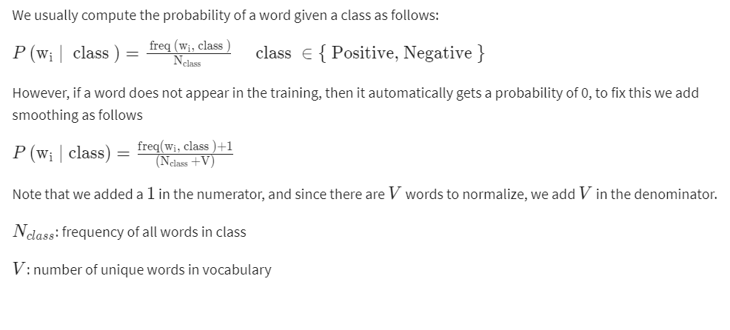

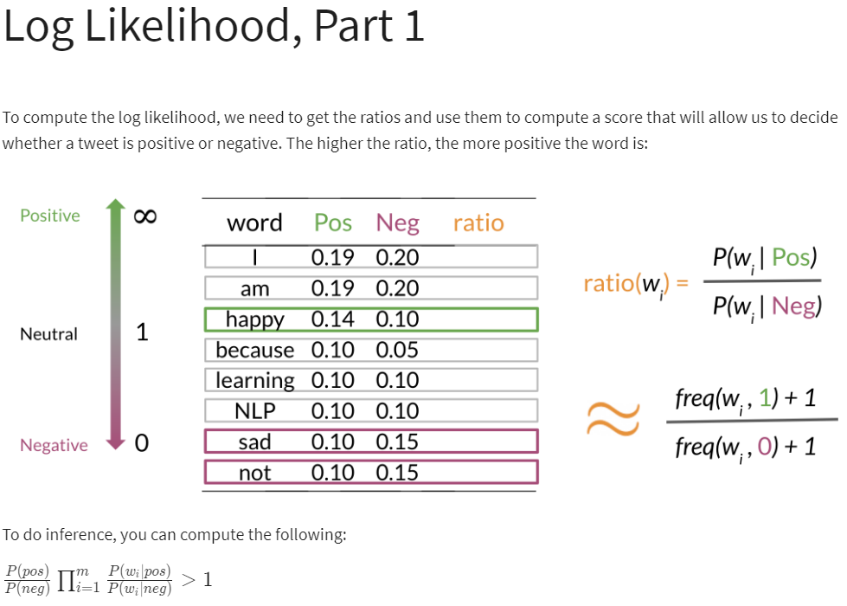

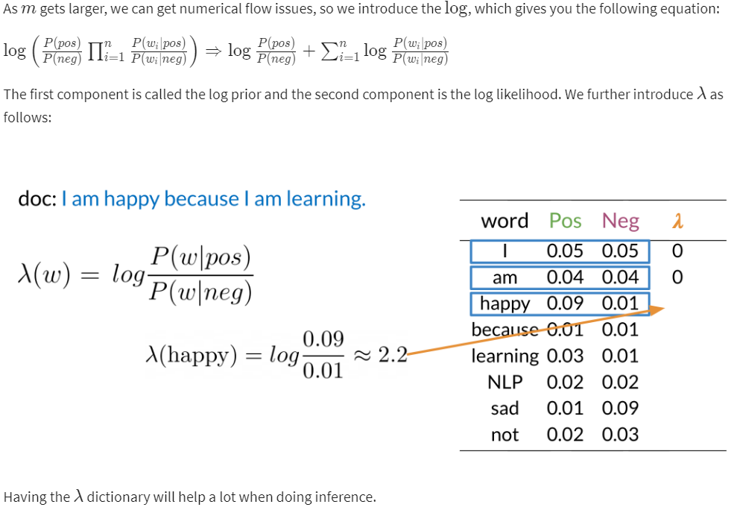

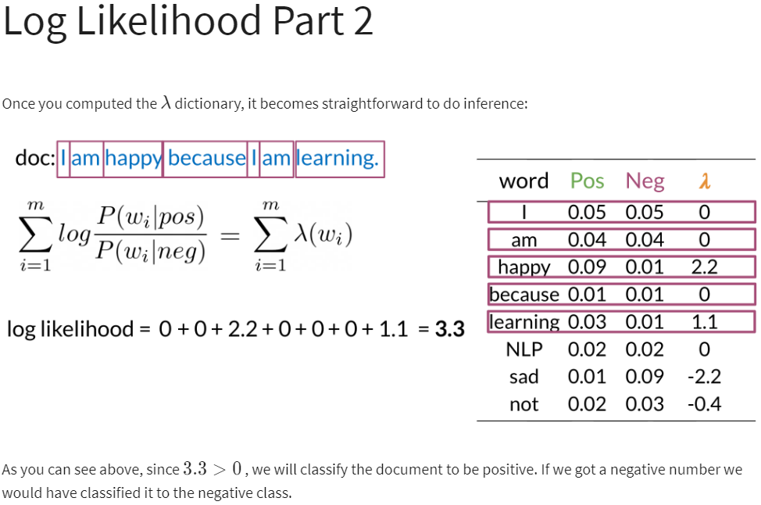

# Training naïve Bayes

To train your naïve Bayes classifier, you have to perform the following steps:

### 1) Get or annotate a dataset with positive and negative tweets

### 2) Preprocess the tweets: process_tweet(tweet) ➞ [w1, w2, w3, ...]:

* Lowercase
* Remove punctuation, urls, names
* Remove stop words
* Stemming
* Tokenize sentences

### 3) Compute freq(w, class):

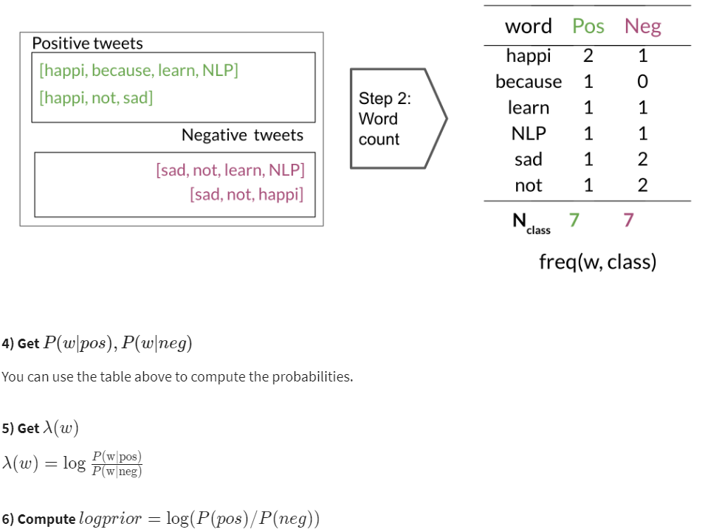

# Testing naïve Bayes

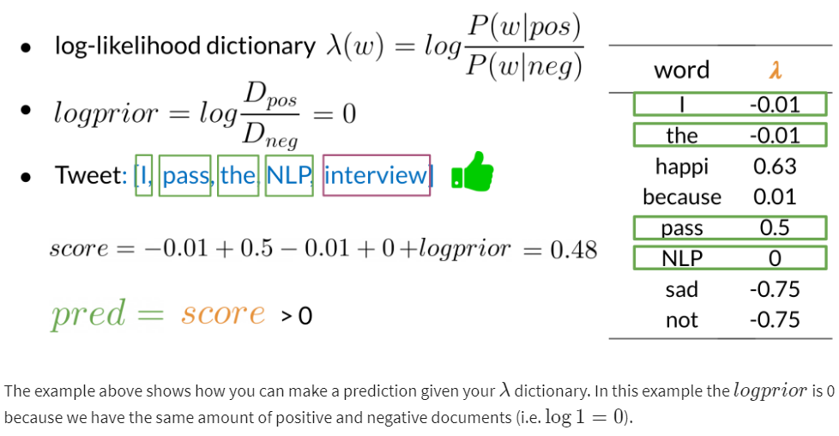

# Applications of Naive Bayes

There are many applications of naive Bayes including:

* Author identification
* Spam filtering
* Information retrieval
* Word disambiguation

This method is usually used as a simple baseline. It is also really fast.

Naïve Bayes Assumptions

Naïve Bayes makes the independence assumption and is affected by the word frequencies in the corpus. For example, if you had the following

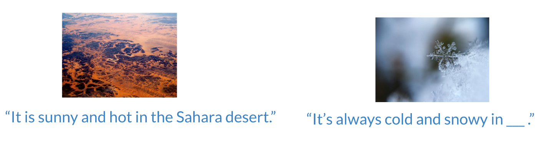

In the first image, you can see the word sunny and hot tend to depend on each other and are correlated to a certain extent with the word "desert". Naive Bayes assumes independence throughout. Furthermore, if you were to fill in the sentence on the right, this naive model will assign equal weight to the words "spring, summer, fall, winter".

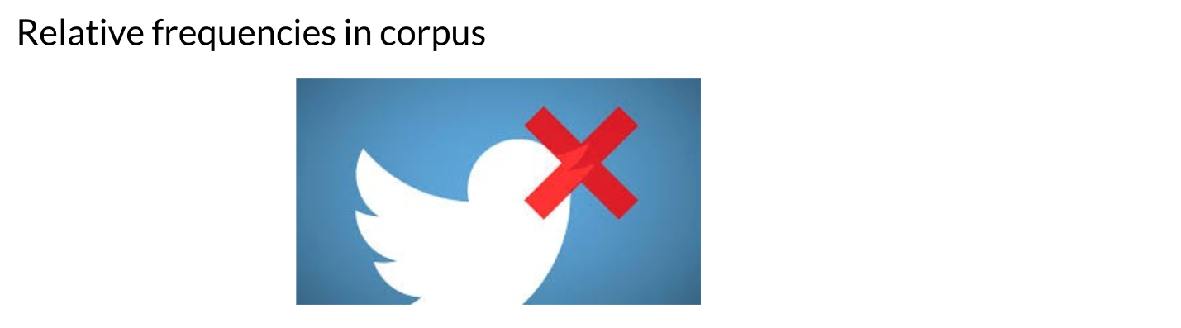

On Twitter, there are usually more positive tweets than negative ones. However, some "clean" datasets you may find are artificially balanced to have to the same amount of positive and negative tweets. Just keep in mind, that in the real world, the data could be much noisier.

# Error Analysis

There are several mistakes that could cause you to misclassify an example or a tweet. For example,

* Removing punctuation
* Removing words

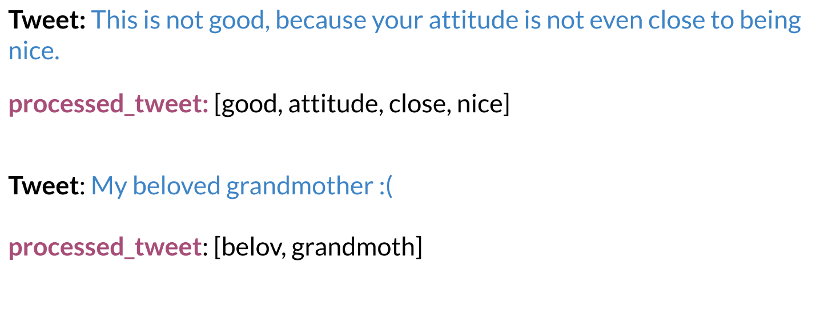

* Word order

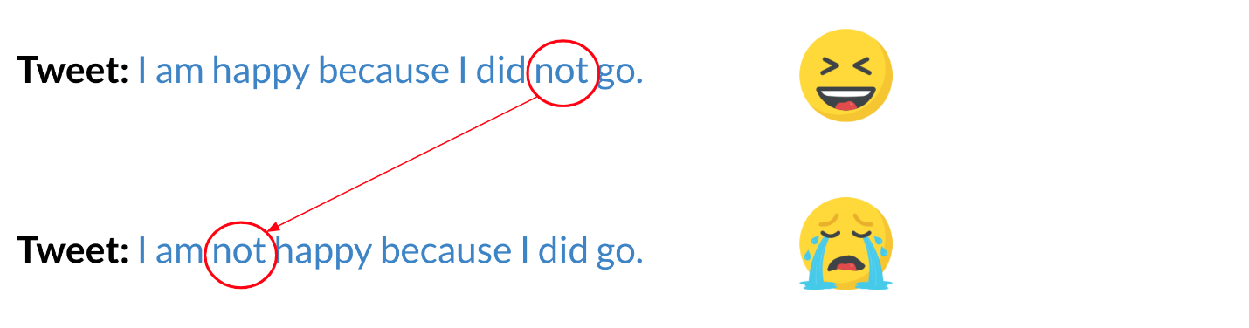

* Adversarial attacks

These include sarcasm, irony, euphemisms.